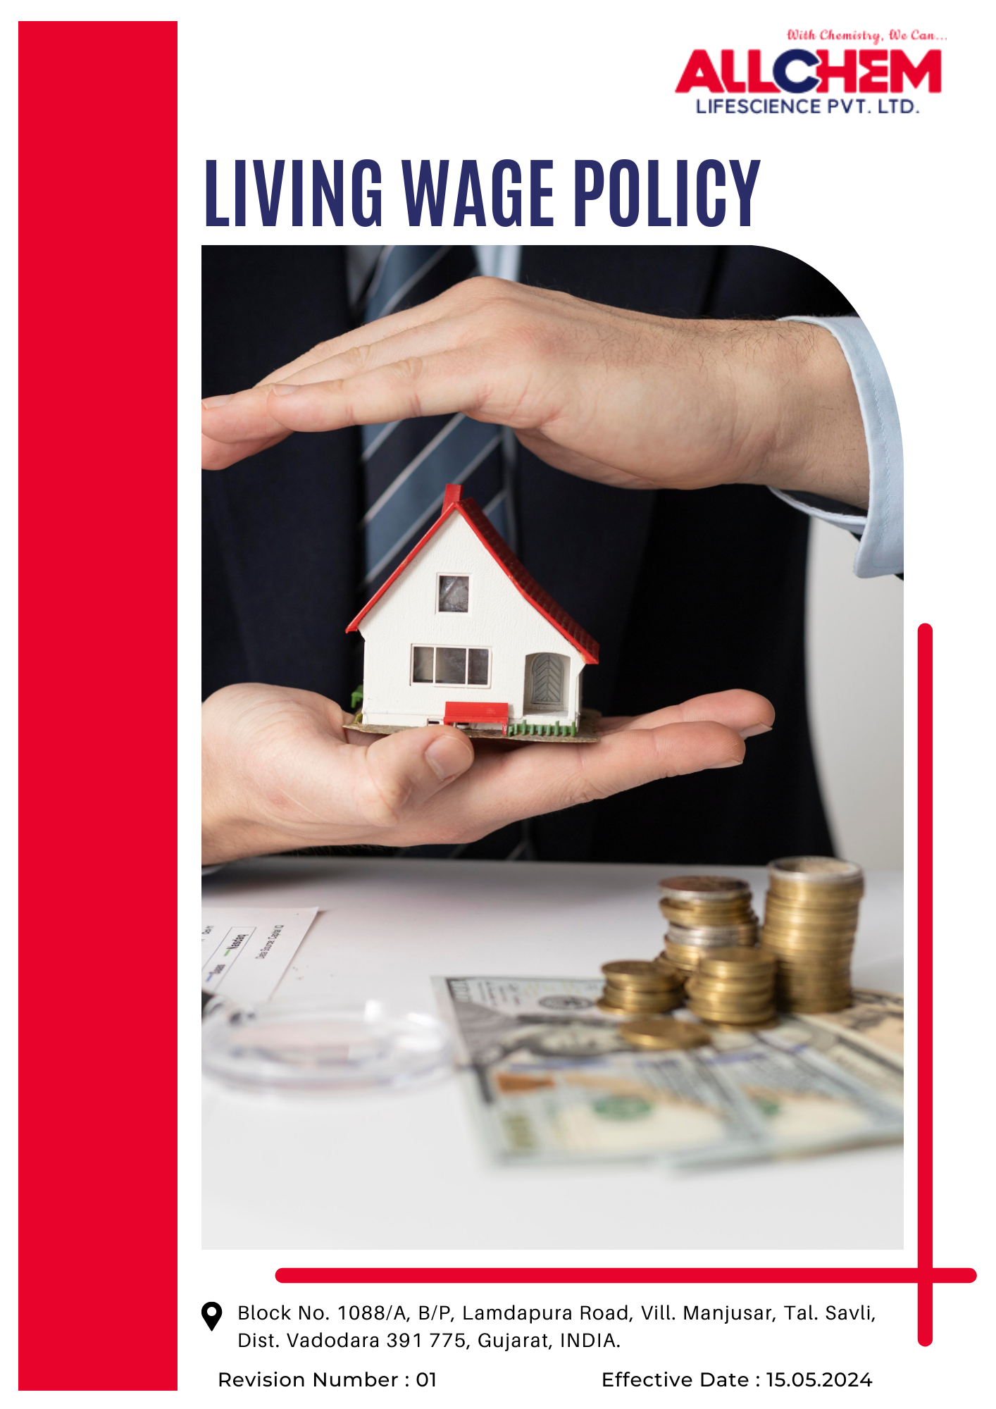

Contents
Preface 2
Scope 3
Policy Declaration 3
Key Action Areas 3
Targets based on our action areas 3
Our Targets in alignment with SDGs 4
Responsibilities 5
Review Mechanism 5
Employee Acknowledgement Form 5

Preface
Fair and equitable wages are essential for employee well-being and sustainable business growth. This Living Wage Policy ensures that all employees receive wages that cover basic living costs, supporting a decent standard of living for them and their families.
A structured approach has been established to determine, implement, and periodically review living wages across all operations. This policy aligns with broader efforts to uphold ethical labor practices, human rights, and social responsibility.
By prioritizing fair compensation, the goal is to create a positive impact within the workforce and the communities in which Allchem operates.
Scope
This policy applies to all Allchem employees, including permanent, contractual, and temporary workers. It ensures wages remain aligned with the cost of living through periodic reviews. Suppliers and partners are encouraged to follow similar fair wage practices.
Allchem Lifescience Pvt. Ltd. | Block No. 1088/A, B/P, Lamdapura Road, Vill. Manjusar, Tal.-Savli, Dist.-Vadodara -391 775, Gujarat, India.

Policy Declaration
Allchem Lifescience Pvt. Ltd. upholds fair compensation practices by ensuring all employees receive a living wage that meets their basic needs and enables a decent standard of living. Using year 2022 as the baseline year, we continuously assess wage structures, implement necessary adjustments, and engage with stakeholders to uphold equitable pay practices across our operations and supply chain.
Key Action Areas
- Regularly evaluate wage levels against living wage benchmarks.
- Implement necessary revisions to align wages with inflation, cost of living changes, and industry standards.
- Engage with suppliers to promote and uphold living wage practices throughout the value chain.
- Collaborate with employees, industry bodies, and labor organizations to refine wage policies.
- Maintain clear documentation of wage structures, conduct periodic audits, and report progress.
- Align fair wage practices with broader ESG commitments.

Targets based on our action areas
- Ensuring Fair and Sustainable Compensation
- Maintain Zero identified living wage gaps till year 2028 through structured wage adjustments and periodic reviews.
- Conduct annual wage assessments to align salaries with inflation, cost-of-living changes, and industry benchmarks.
- Ensure that all employees at Allchem Lifescience Pvt. Ltd. regularly receive a living wage, with periodic reviews and adjustments to maintain alignment with recognized living wage benchmarks.
- Strengthening Wage Policies and Transparency
- Publish annual reports on living wage progress, wage structure updates, and related policy improvements.
- Implement grievance mechanisms to address wage-related concerns and promote accountability.
- Extending Living Wage Commitment to the Supply Chain
- Engage with 100% key suppliers to assess wage structures and support the adoption of living wage policies by year 2028.
- Integrate living wage criteria into supplier audits and procurement policies to encourage responsible sourcing ensure it’s compliance by year 2028.
- Supporting Employee Financial Well-being
- Introduce one financial literacy program tiil year 2028 to enhance employees understanding of personal finance, savings, and long-term financial planning.
- Provide additional employee benefits, such as health insurance, education support, and financial assistance, to improve overall economic stability.
Our Targets in alignment with SDGs
- SDG 1: No Poverty – Ensuring all employees receive a living wage helps eliminate poverty by providing fair compensation that meets basic needs.
- SDG 8: Decent Work and Economic Growth – Conducting wage assessments, ensuring fair pay, and engaging suppliers in living wage practices promote decent work conditions and sustainable economic growth.
- SDG 10: Reduced Inequalities – Addressing wage gaps, implementing transparent wage policies, and supporting employee financial well-being help reduce income inequality within the organization and supply chain.
- SDG 12: Responsible Consumption and Production – Integrating living wage criteria into procurement policies encourages ethical and sustainable sourcing across the supply chain.
Responsibilities
- The HR Department ensures fair wages through periodic assessments and alignment with living wage benchmarks.
- The Procurement Team integrates living wage criteria into sourcing and monitors supplier compliance.
- The Finance Department evaluates wage adjustments for financial feasibility and long-term sustainability.
- The Compliance Team audits adherence to living wage commitments and enforces corrective actions.
- Senior Management oversees policy execution, wage revisions, and ESG alignment.

Review Mechanism
- The Living Wage Policy will be reviewed every two years, or sooner if required by the HR Manager, to ensure it remains aligned with inflation rates, cost-of-living changes, industry standards, and regulatory developments.
- Annual wage assessments and internal audits will be conducted to evaluate compliance with living wage commitments, identify gaps, and implement corrective actions. Findings will be documented and reported to senior management for review and policy refinement.
- Employee feedback, supplier inputs, and insights from labor organizations, industry bodies, and external stakeholders will be actively gathered and integrated to enhance wage structures and address any concerns.
- Compliance with living wage requirements will be monitored through periodic supplier audits, ensuring key partners align with fair wage principles and corrective actions are taken when necessary.
Effective Date | : 15.05.2024
Next Review Date | : 15.05.2026
Approved By | :

Employee Acknowledgement Form
I acknowledge that I have received, read, and understood the Living Wage Policy of Allchem Lifescience Pvt. Ltd. I agree to uphold the principles outlined in this policy, including fair compensation, periodic wage assessments, and alignment with living wage benchmarks.
I understand my role in supporting the company’s commitment to ensuring fair and sustainable wages and will take necessary actions to uphold wage transparency and compliance. I also acknowledge my responsibility to report any wage-related concerns or non-compliance issues through the appropriate channels.
By signing this acknowledgment, I confirm my commitment to contributing to Allchem Lifescience’s fair wage initiatives and fostering an equitable and responsible work environment.
Employee Name  Employee ID  Date  Signature | :_______________________________  :_______________________________ :________________________________  : _______________________________

